**Amazon AWS**

***Workshop 1:* Create and connect to an instance**

**Step 1:** build a network (VPC)

click on AWS Console

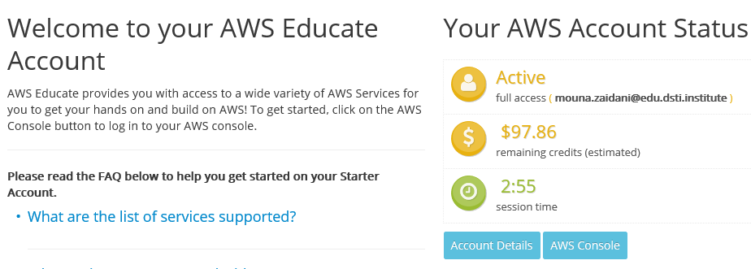



We land on AWS management Console

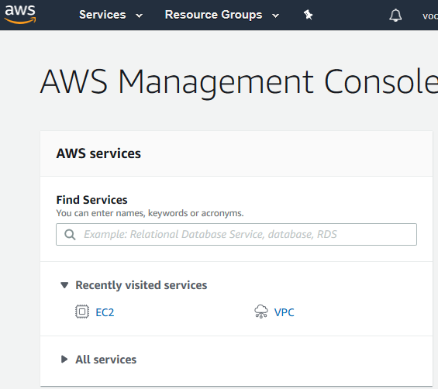

Launching a new instance🡪EC2





For that we need a VPC (do not use the default VPC, we need to create our own VPC)

Under **services**, type **VPC** (Isolated Cloud Resources)

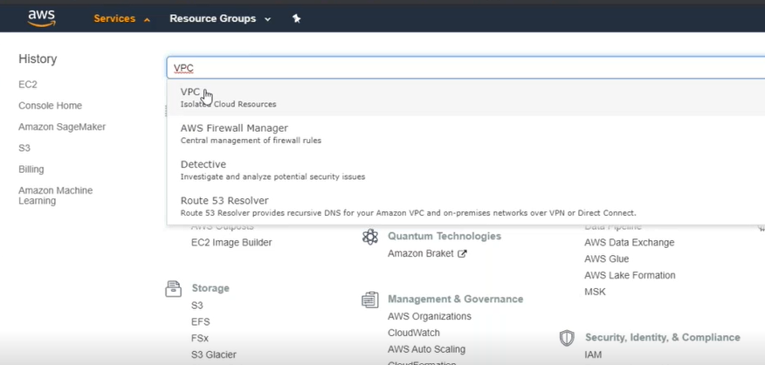



Then, click on **Your VPCs**

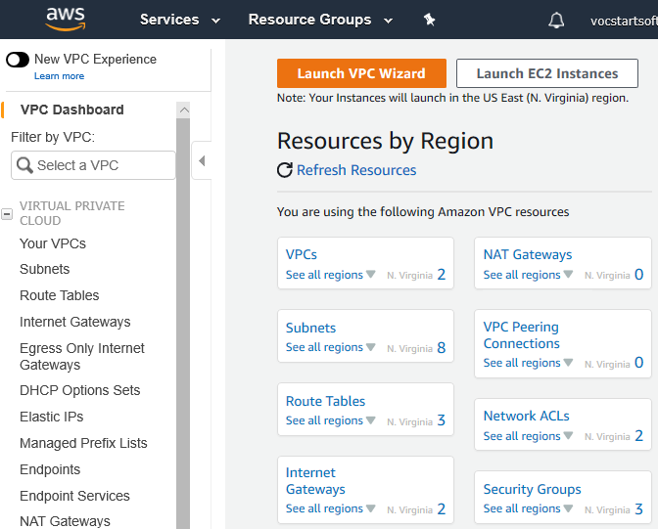



After, click on **create VPC**

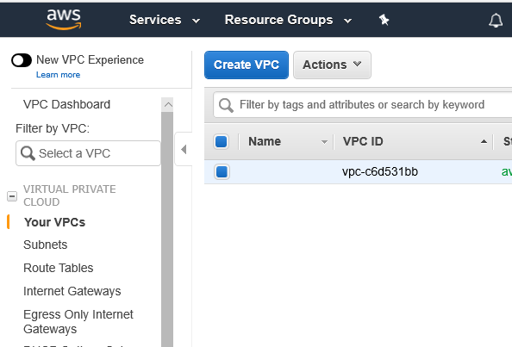



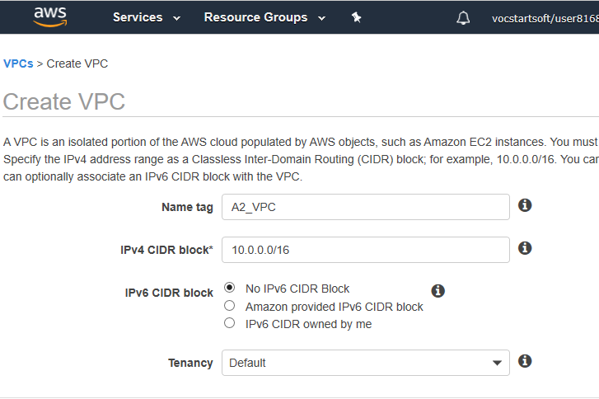



And, we just create a VPC:

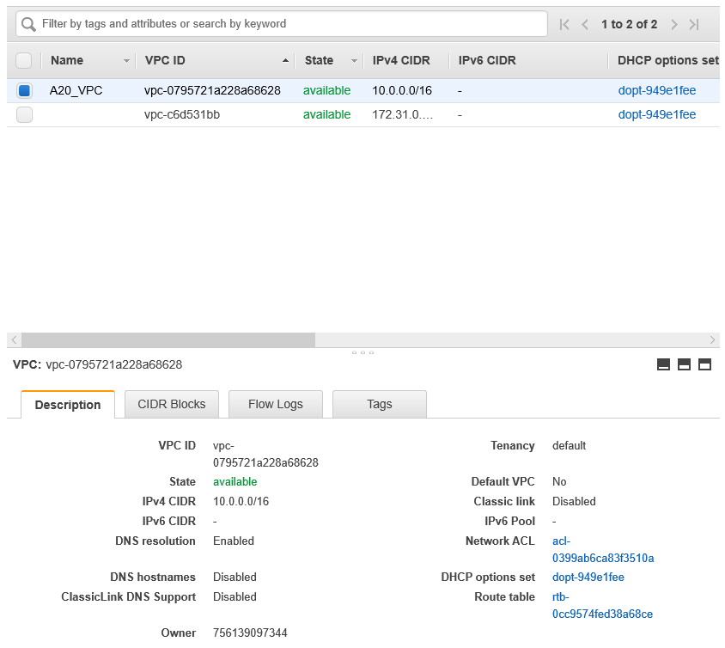



**Step 2:** Creating a subnet

Under **Subnets** 🡪 we click create subnet

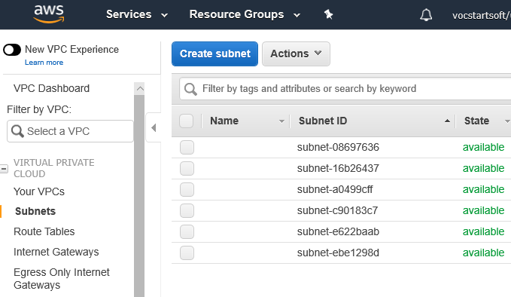



We choose the VPC we just created, and an **availability zone** (AZ)

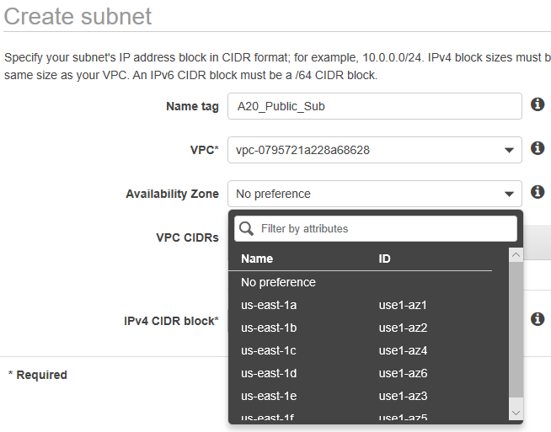



And most importantly, put a valid **IPv4**:

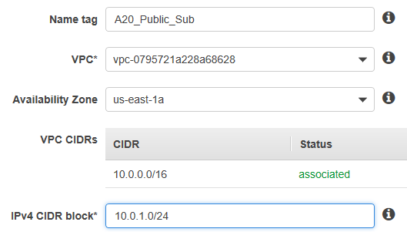



Now, we have one **VPC** and one **Subnet 🡪** Now we create another subnet (private)

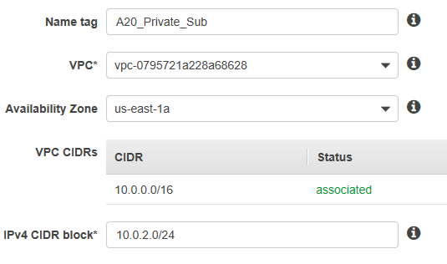



Now, that we have one **private** subnet and a **public** subnet

The difference between a private and public subnet is the way traffic is routed, weather it goes to internet gateway or not, now we need to configure properly our private and public subnet.

Public subnet gets its traffic routed towards an internet gateway🡪 we need to put an internet gateway.

Under **Internet Gateway** 🡪click on create internet gateway

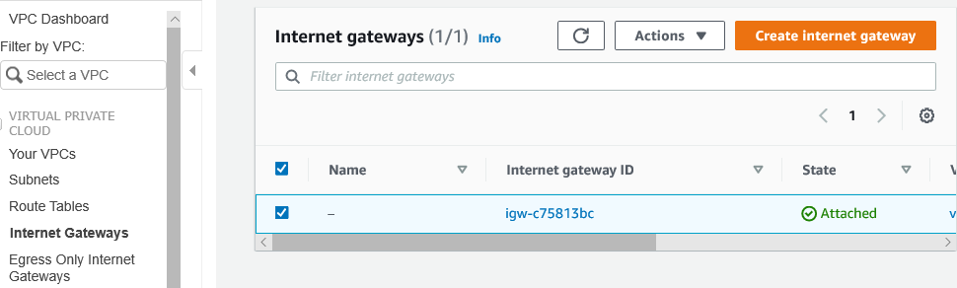



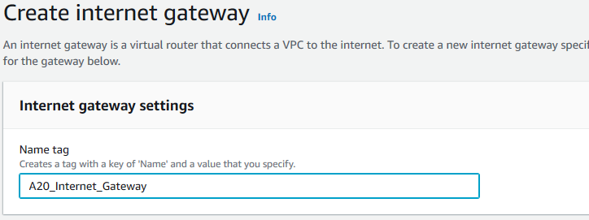



Once created, on need to attached it to The VPC

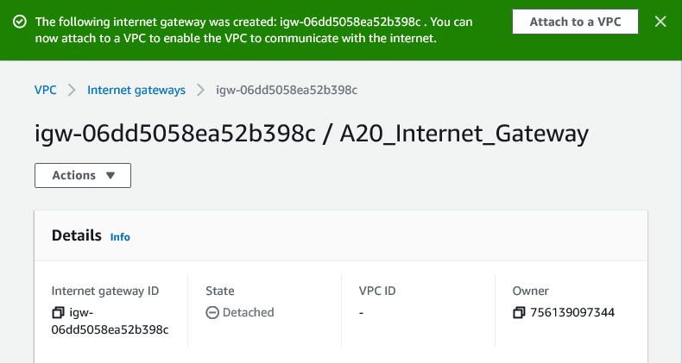



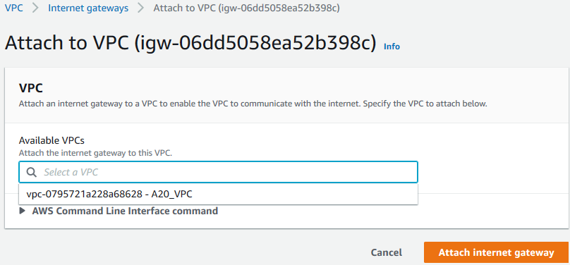



Now our VPC has an internet gateway, but the traffic still needs to be routed to an internet gateway:

On public subnets, we click on **Route Table,** and you click on the ID of the route table

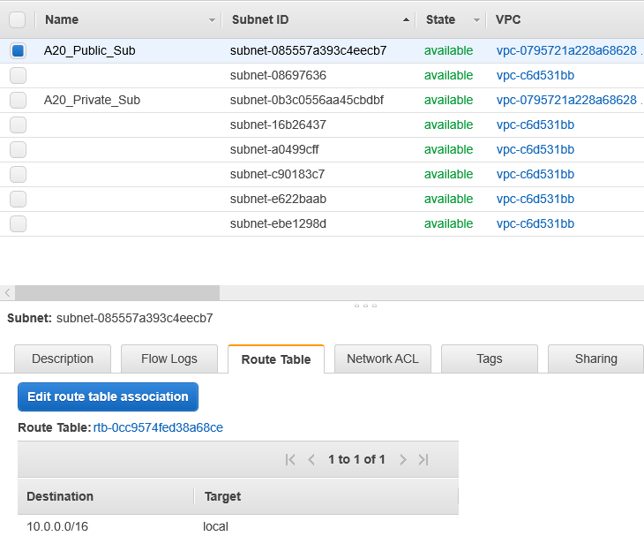



After that, we will land in route tables section, and we click on **edit routes**

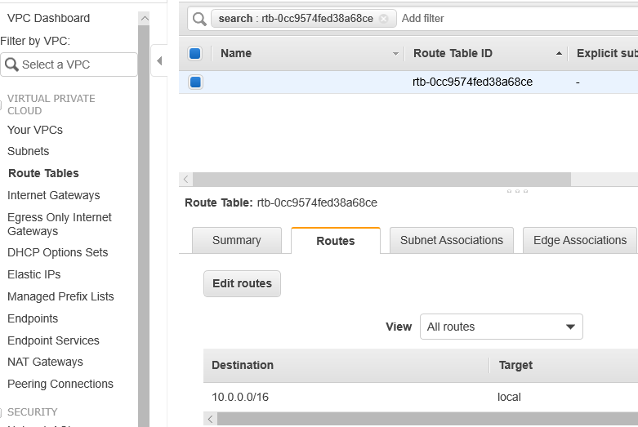



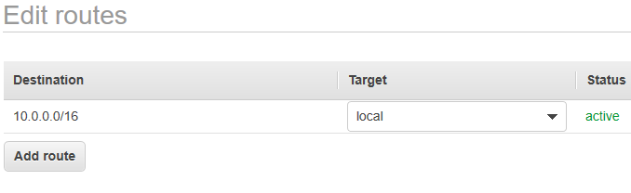



And on **Target**, we choose our internet gateway

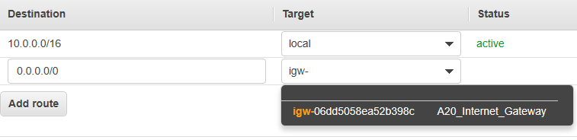



And it’s done, now we have our VPC, two subnets, an internet gateway, and within the subnet we configured our route table to go to our internet gateway, now we configurated our Public subnet.

Now, for the private subnet configurations, same steps, we go to route tables 🡪 create route tables 🡪

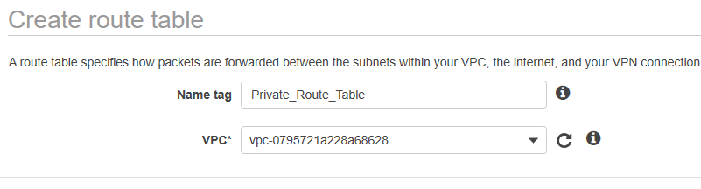



Once done, we go back to **Subnets 🡪** select our private subnet 🡪 select **Route tables 🡪** click on **edit route table association**

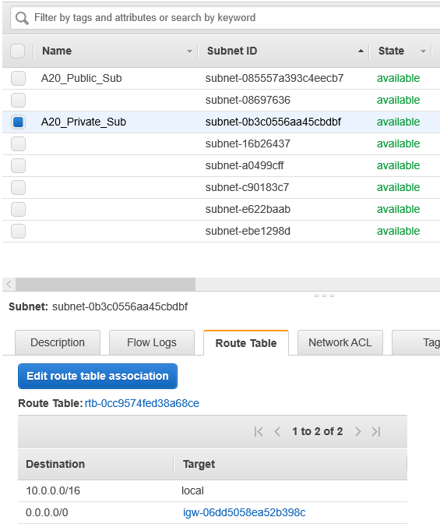



Then, select the private route table we just created.

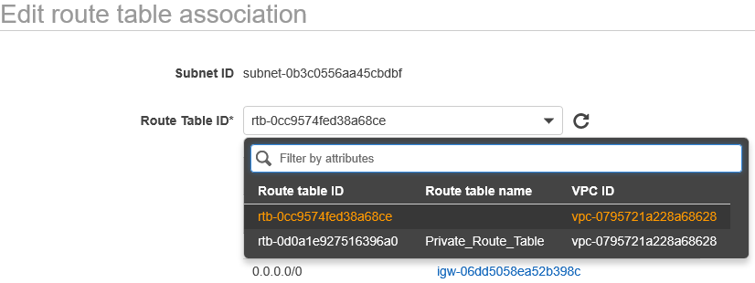



Now, my private subnet and my public subnet have different route tables.

**Step 3:** Launching an instance

GO back to **services** 🡪 Select **EC2 🡪** click on **launch instance**

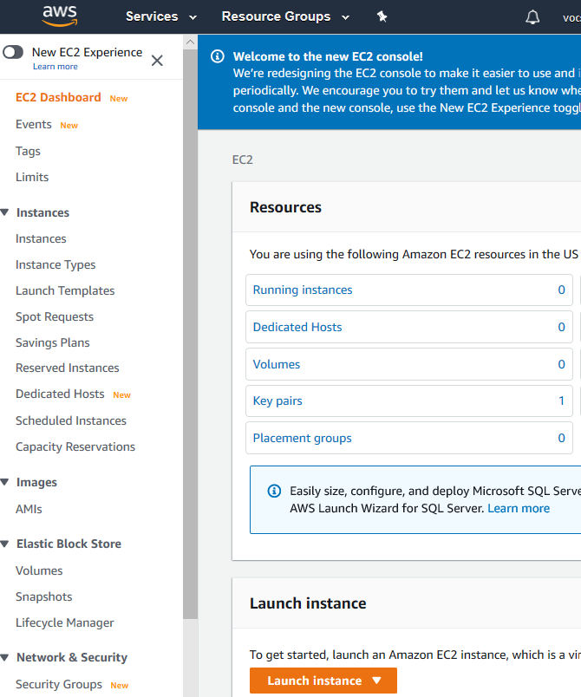



We select an **Amazon machine image (AMI),** we select the first one here:

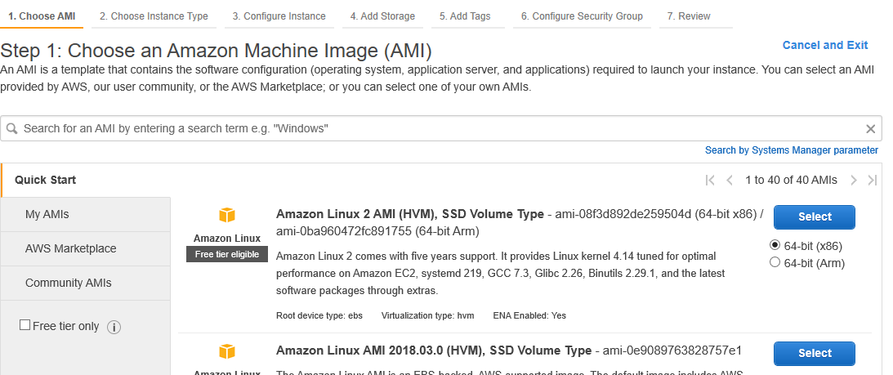



After that, we select an Instance type:

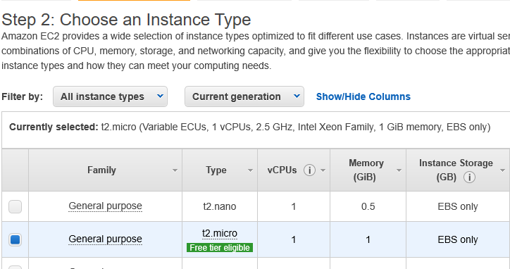



Next, we configure the instance details, we select our VPC, and the public subnet and enable the auto assigned IP:

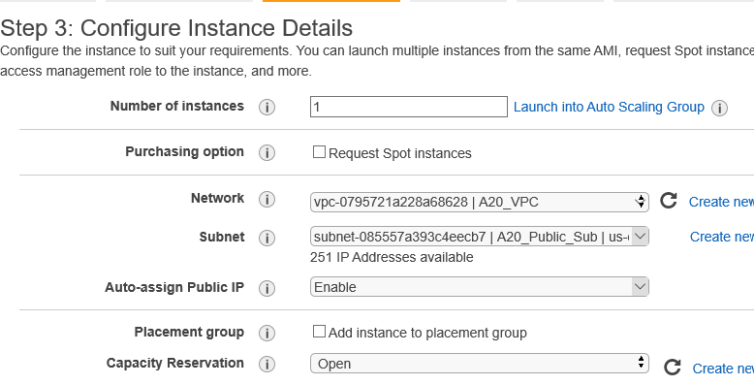



In step 4, we add storage:

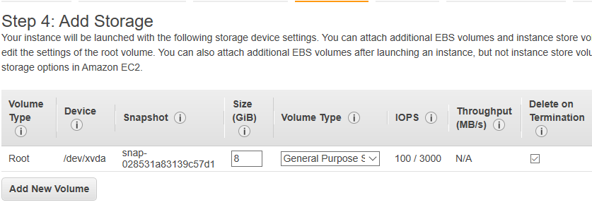



In step 5, we click on **Add tag 🡪 we create a name for our instance**

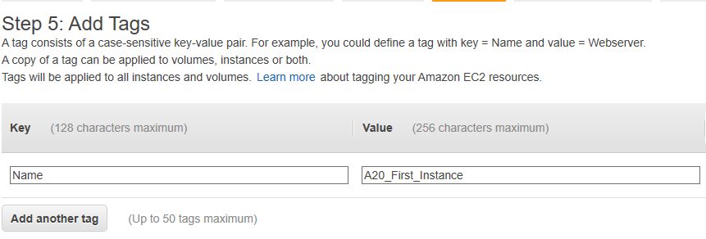



Next, we configure the security group and we create a new one 🡪 click on **create a new security group:**

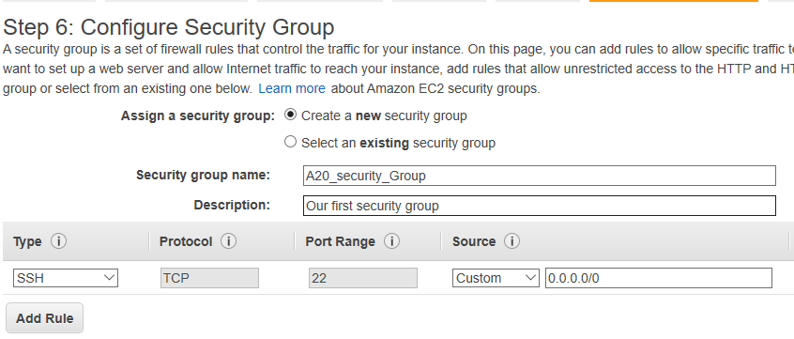



Next, for the final step 🡪click on **review and launch**

Once this is done 🡪 click on **Launch**

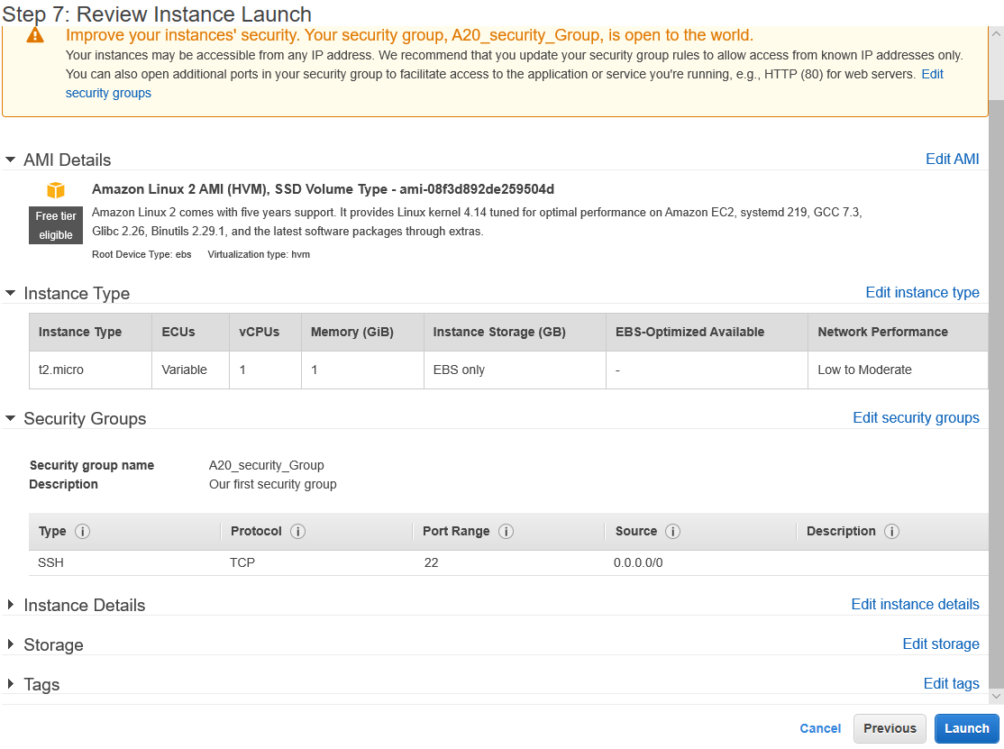



When we click launch 🡪 we need to **create a new key pair** and **download it**, very important step as you will not be able to connect to your instance without this key pair.

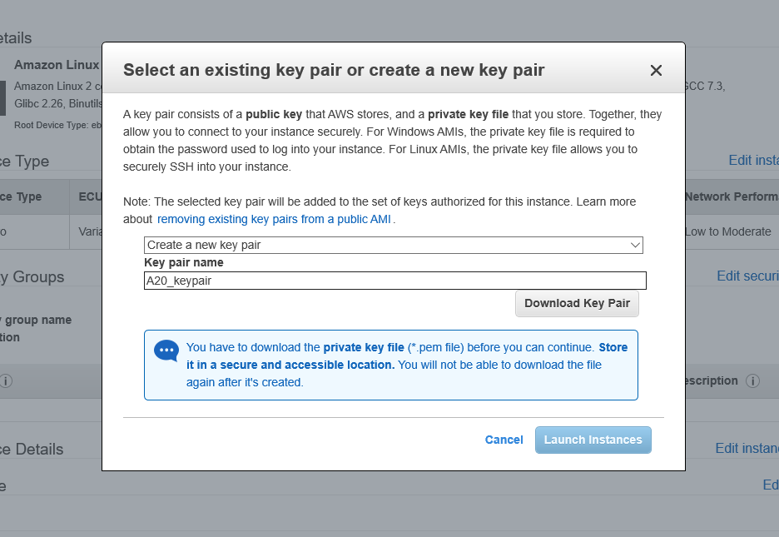



Finally, here, we click on **Launch instance 🡪**then **view instance**

**Now our instance is created and it’s running.**

